 | 12.1.18 Editors - Geometry Nodes Editor - Header - Add Menu - Texture
Table of content
Detailed table of content 1
Add menu - Texture 1
Noise Texture 1

Detailed table of content
Detailed table of content
Detailed table of content 1
Add menu - Texture 1
Noise Texture 1
Inputs 1
Vector 1
Scale 2
Detail 2
Roughness 2
Distortion 2
Properties 2
Dimensions 2
Output 2
Factor 2
Color 2

Add menu - Texture
Texture nodes.

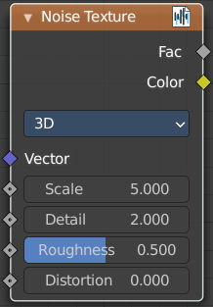
Noise Texture
Add a noise texture.

Inputs

Vector
Vector input

Scale
The scale of the noise texture.

Detail
The detail of the noise texture.

Roughness
The roughness of the noise texture.

Distortion
The distortion of the noise texture.

Properties

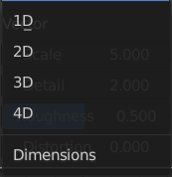
Dimensions
How many dimensions to use for the noise texture.

Output

Factor
Factor output.

Color
Color output.

